Five national charities team up for Anti-Bullying Week 2014
http://www.kidscape.org.uk/beingme
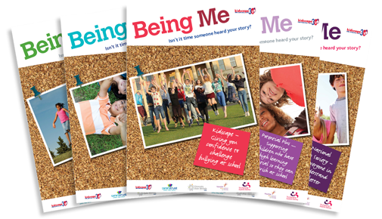
This year Kidscape is supporting national Anti-Bullying Week’s aim to stop bullying by launching the Being Me series, which is designed to give children and young people an insight into the potential challenges being faced by their peers. Kidscape has partnered with Carers Trust, Diversity Role Models, Potential Plus and The National Autistic Society to create this unique anti-bullying resource for schools.
Peter Bradley, Kidscape’s Director of Services says “Thousands of children are bullied simply because they are different, and crucially, because those differences are not appreciated and understood. This year’s Anti-Bullying Week aims to stop bullying for all, and one powerful way to do that is to encourage children to celebrate difference.”
The series has been developed and produced by journalist Jenny Hulme, who met with children and the charities, hearing their stories of how cruel words, social exclusion or physical abuse cause harm and distress. It offers five powerful diary entries and short stories that typify ‘a day in the life’ of the young people that each charity supports. The whole series will be free to download for schools and professionals who work with children and young people.
Peter adds “Many teachers are doing excellent work to promote empathy and kindness, however, much more needs to be done. Being Me is a resource that they can use to start conversations about difference and tolerance. We want it to be used to give all children the skills and understanding to respect difference, to feel included and to get to better know their peers.”
Claude Knights, Kidscape’s CEO says: “I am delighted that Kidscape has been able to join with these four wonderful charities to create Being Me. We know that bullying can have devastating impacts on the health, wellbeing and learning of children and young people, and we have therefore developed Being Me to support schools’ efforts in fostering kind and safe environments for their students.”
-ENDS-
For further information about the Being Me resource*, or to arrange a press interview, please contact:
Lucy Taylor | Communications Officer
Email: lucy@kidscape.org.uk | Tel: 020 7730 3300
* For comments regarding the specific areas in which each charity partner works, please contact the individual charity directly.
Notes to editors
- Kidscape is the UK’s longest established anti-bullying charity. The mission of Kidscape is to ensure children live in a safe and nurturing environment. By providing training, support and advice to children, parents, schools and those in professional contact with young people, we enable them to gain knowledge and develop the confidence and skills to challenge abuse and bullying in all its forms.
- Anti-Bullying Week (ABW) is an annual UK event held in the third week in November which aims to raise awareness of bullying and to offer ways in which schools, organisations and individuals can work together to prevent it. It is organised by the Anti-Bullying Alliance (ABA) in England. The Anti-Bullying Alliance is a coalition of approximately 60 member organisations working together to stop bullying and create safe environments in which children and young people can live, grow, play and learn. This year’s ABW theme is to stop the bullying of all children, particularly those with special educational needs and disabilities, as research shows these children are more likely to experience bullying.
- Over 8 out of 10 young people with learning difficulties have experienced bullying (source: Anti-Bullying Alliance 2014).
- 66% of young people say they have been bullied about their physical appearance or for being different (source: NSPCC 2013).
- Up to a third of children are involved in bullying (source: University of Warwick 2014).
- Pictured below: Claude Knights, Kidscape CEO (left) and Peter Bradley, Director of Services (right).
